M.SC. I.T. SEM 3
A.Y. 2024-25

ADVANCED ARTIFICIAL INTELLIGENCE

PRACTICAL MANUAL

BY MRS. PALLAVI NISHANDAR AHIRE
PRACTICAL NO. 01 :
Implementing advanced deep learning algorithms such as convolutional neural networks (CNNs) or recurrent neural networks (RNNs) using Python libraries like TensorFlow or PyTorch.

Description :
- Write about RNN in short, we are using RNN approach.
- students supposed to write about the library which they are using in the following code.
Steps to follow:
You need to install the following library.
Pip install tensorflow

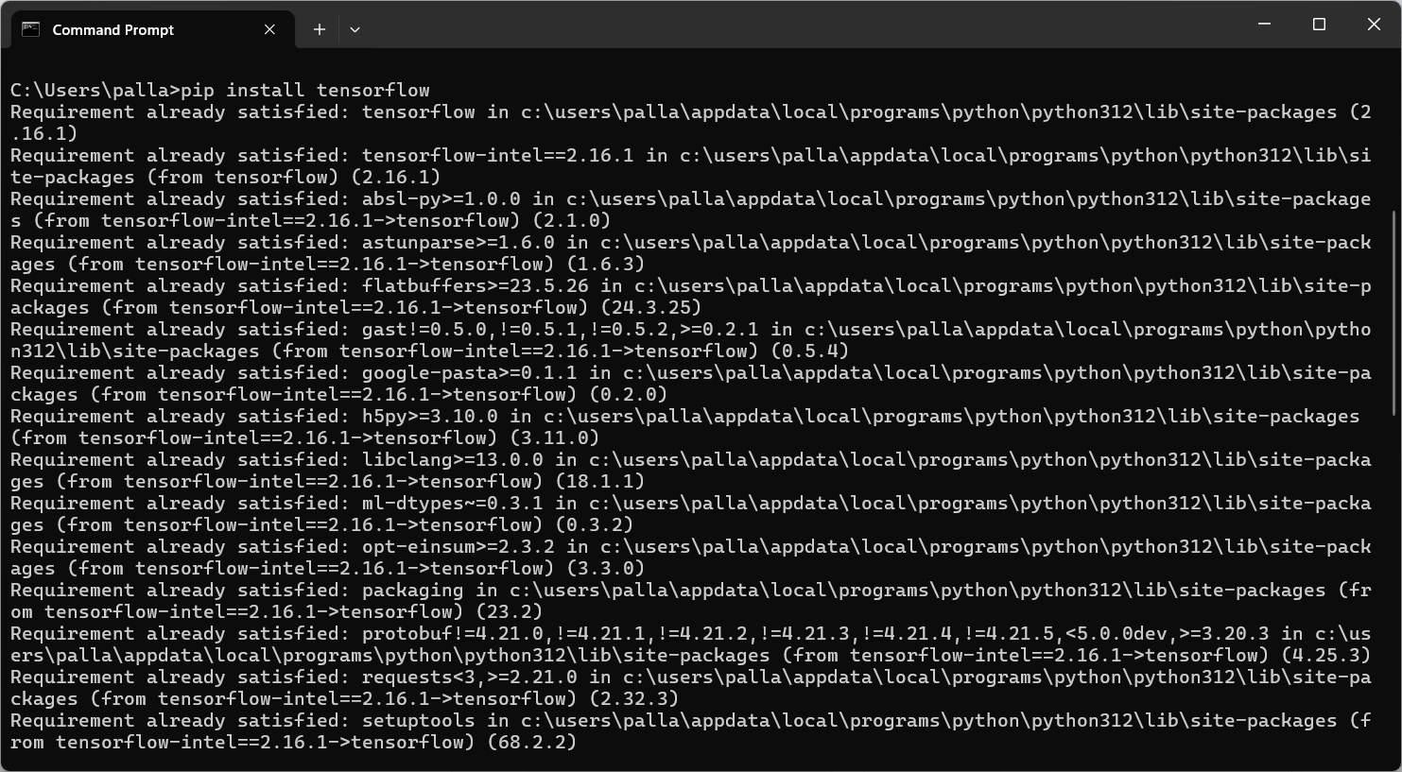
Python code: using RNN
import tensorflow as tf
import numpy as np
from tensorflow.keras import layers, models
from tensorflow.keras.preprocessing.text import Tokenizer
from tensorflow.keras.preprocessing.sequence import pad_sequences
from sklearn.model_selection import train_test_split
from sklearn.metrics import accuracy_score

# Sample data (For a full implementation, replace this with a larger dataset)
texts = [
"I love this movie",
"This movie is terrible",
"Amazing plot and great acting",
"I hate this movie",
"The movie was okay, not great",
"Fantastic experience, very enjoyable",
"Not worth watching",
"I would watch it again, highly recommend",
"I dislike the plot but the acting was good",
"A masterpiece in cinema"
]
labels = [1, 0, 1, 0, 0, 1, 0, 1, 0, 1] # 1: Positive, 0: Negative

# Tokenize the text data
tokenizer = Tokenizer(num_words=10000)
tokenizer.fit_on_texts(texts)
X = tokenizer.texts_to_sequences(texts)

# Pad sequences to ensure they are of the same length
X = pad_sequences(X, maxlen=10)

# Train-test split
X_train, X_test, y_train, y_test = train_test_split(X, labels, test_size=0.2, random_state=42)

# Ensure data is in the right format
X_train = np.array(X_train)
X_test = np.array(X_test)
y_train = np.array(y_train)
y_test = np.array(y_test)

# Define the LSTM-based RNN model
model_rnn = models.Sequential([
layers.Embedding(input_dim=10000, output_dim=64, input_length=10),
layers.LSTM(64, return_sequences=False),
layers.Dense(64, activation='relu'),
layers.Dense(1, activation='sigmoid') # Binary classification (positive/negative)
])

model_rnn.compile(optimizer='adam', loss='binary_crossentropy', metrics=['accuracy'])

# Train the RNN model (LSTM)
model_rnn.fit(X_train, y_train, epochs=5, batch_size=2, validation_data=(X_test, y_test))

# Evaluate the model
y_pred_rnn = (model_rnn.predict(X_test) > 0.5).astype(int)

print("RNN (LSTM) Accuracy:", accuracy_score(y_test, y_pred_rnn))

Output:
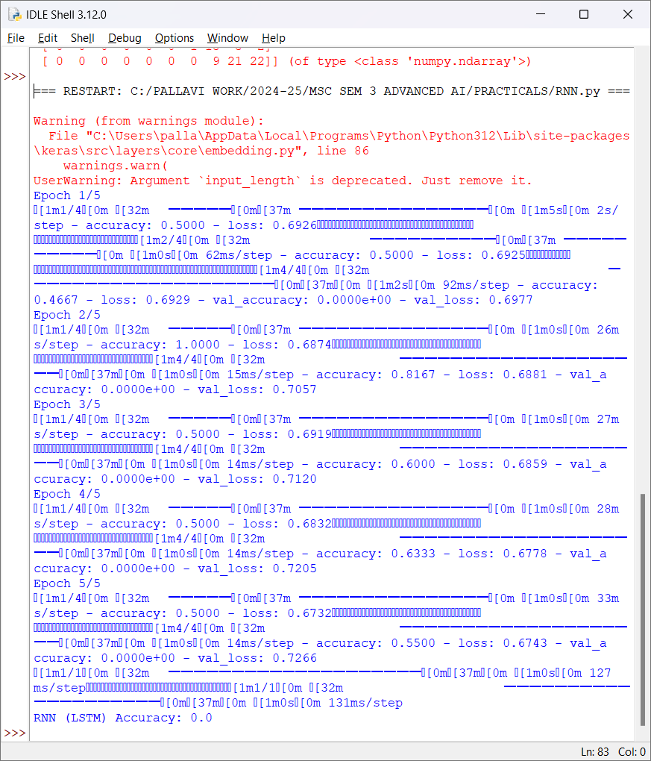

PRACTICAL NO. 02 :
Building a natural language processing (NLP) model for sentiment analysis.

Description :
- Write about NLP in short
- Write about sentiment analysis in short.
- Students supposed to write about the library which they are using in the following code .
Steps to follow:
You need to install the following library.
Pip install nltk
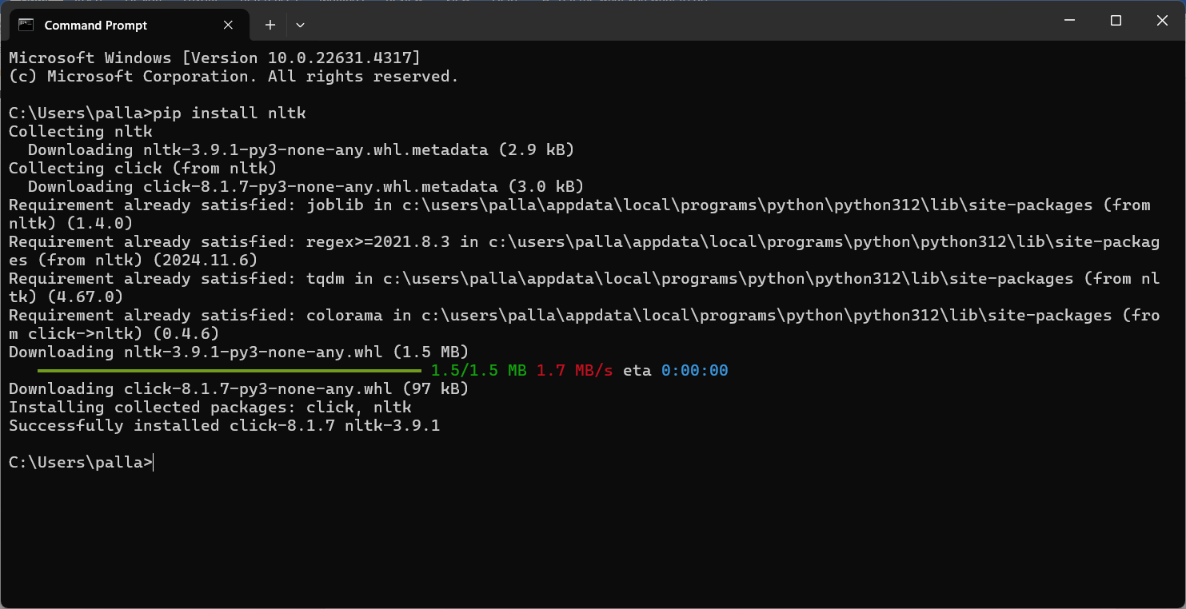
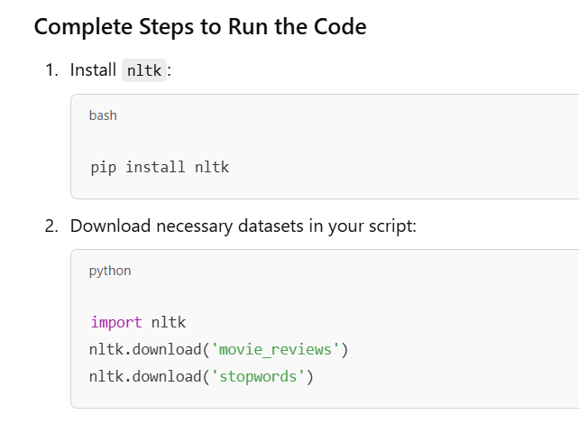
Python code:
import nltk
import string
import numpy as np
import pandas as pd
from sklearn.model_selection import train_test_split
from sklearn.feature_extraction.text import TfidfVectorizer
from sklearn.linear_model import LogisticRegression
from sklearn.metrics import accuracy_score, classification_report
from nltk.corpus import movie_reviews
from sklearn.pipeline import make_pipeline
from sklearn.preprocessing import LabelEncoder

# Download NLTK data (movie reviews dataset)
nltk.download('movie_reviews')
nltk.download('stopwords')

# Loading the movie reviews dataset from nltk
documents = [(list(movie_reviews.words(fileid)), category)
for category in movie_reviews.categories()
for fileid in movie_reviews.fileids(category)]

# Preprocessing the data: Combine text and labels
texts = [' '.join(doc) for doc, _ in documents]
labels = [category for _, category in documents]

# Splitting the data into train and test sets
X_train, X_test, y_train, y_test = train_test_split(texts, labels, test_size=0.2, random_state=42)

# Initialize the vectorizer (convert text to features) and classifier
vectorizer = TfidfVectorizer(stop_words='english', max_features=1000)
classifier = LogisticRegression(max_iter=1000)

# Create a pipeline that first vectorizes the text and then trains the classifier
model = make_pipeline(vectorizer, classifier)

# Train the model
model.fit(X_train, y_train)

# Predict the labels for the test set
y_pred = model.predict(X_test)

# Evaluating the model
accuracy = accuracy_score(y_test, y_pred)
report = classification_report(y_test, y_pred)

print(f"Accuracy: {accuracy}")
print("Classification Report:")
print(report)

# Example prediction
example_text = ["I love this movie, it's amazing!", "I hate this movie, it's terrible."]
predictions = model.predict(example_text)

print("\nPredictions for Example Texts:")
for text, pred in zip(example_text, predictions):
print(f"Text: {text} -> Predicted Sentiment: {pred}")

Output:
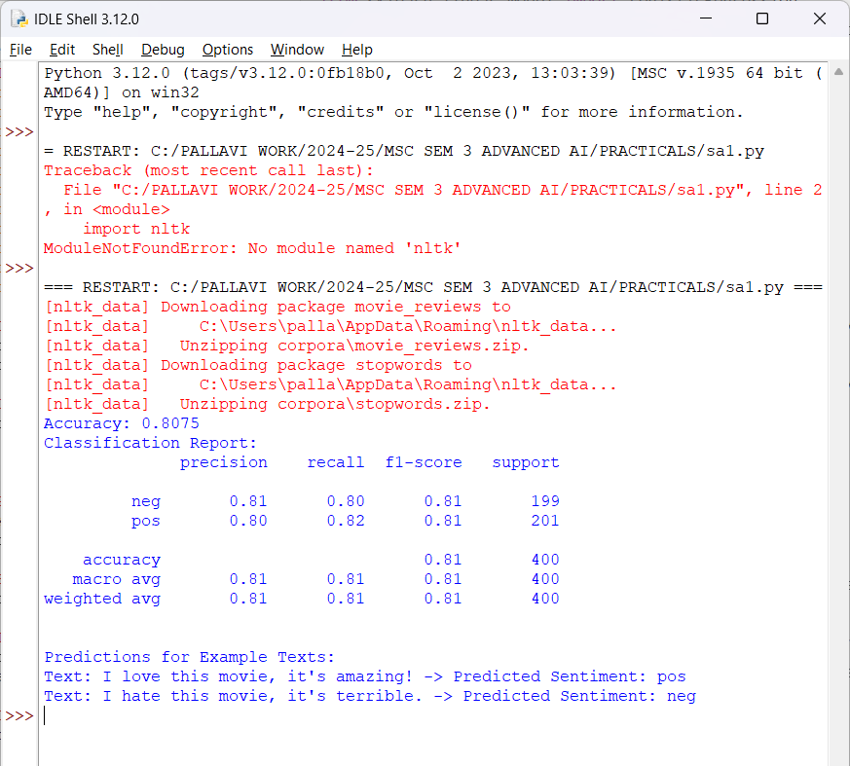

PRACTICAL NO. 03 :
Creating a chatbot using advanced techniques like transformer models.

Description :
Students supposed to write about the library transformers torch in detail.
Steps to follow:
You need to install the following library.
pip install transformers torch
when you are installing above library on command prompt, it will take little time to get install with the following steps shown below:
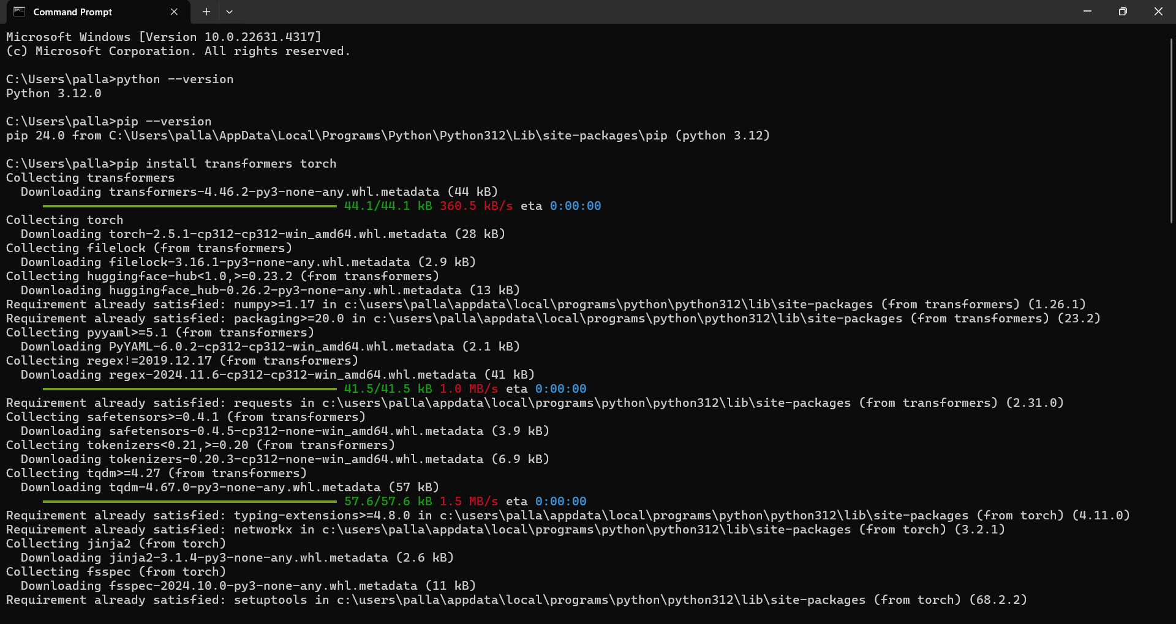
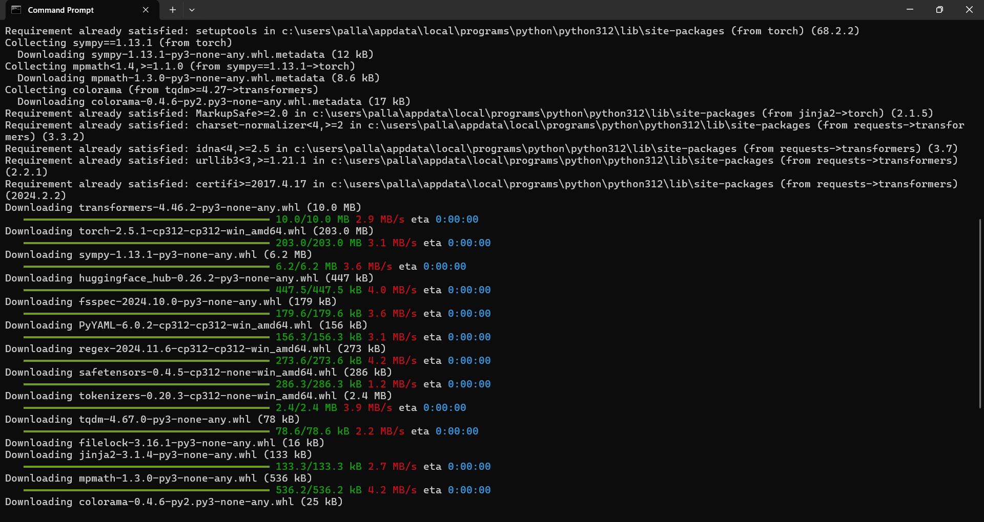
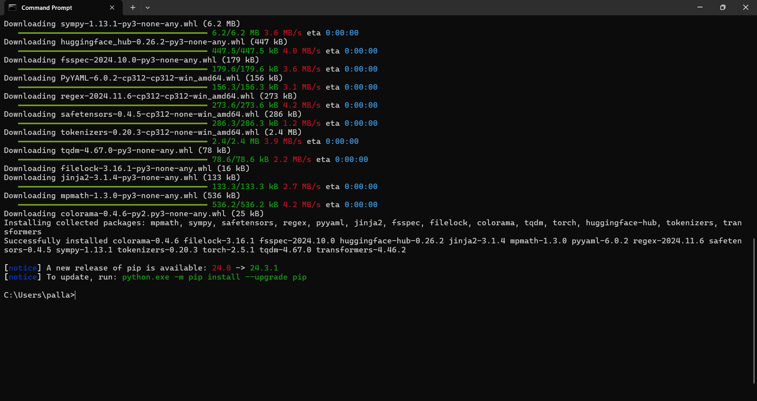
Now the library is installed successfully.
Now write the following python script and save it as chatbot.py at desired location.
Python code:
import torch
from transformers import GPT2LMHeadModel, GPT2Tokenizer

# Load the pre-trained GPT-2 model and tokenizer
model_name = "gpt2"
tokenizer = GPT2Tokenizer.from_pretrained(model_name)
model = GPT2LMHeadModel.from_pretrained(model_name)

# Set the model to evaluation mode
model.eval()

def generate_response(prompt, max_length=50):
input_ids = tokenizer.encode(prompt, return_tensors="pt")

# Generate response
with torch.no_grad():
output = model.generate(input_ids, max_length=max_length, num_return_sequences=1, pad_token_id=50256)

response = tokenizer.decode(output[0], skip_special_tokens=True)
return response

print("Chatbot: Hi there! How can I help you?")
while True:
user_input = input("You: ")
if user_input.lower() == "exit":
print("Chatbot: Goodbye!")
break

response = generate_response(user_input)
print("Chatbot:", response)

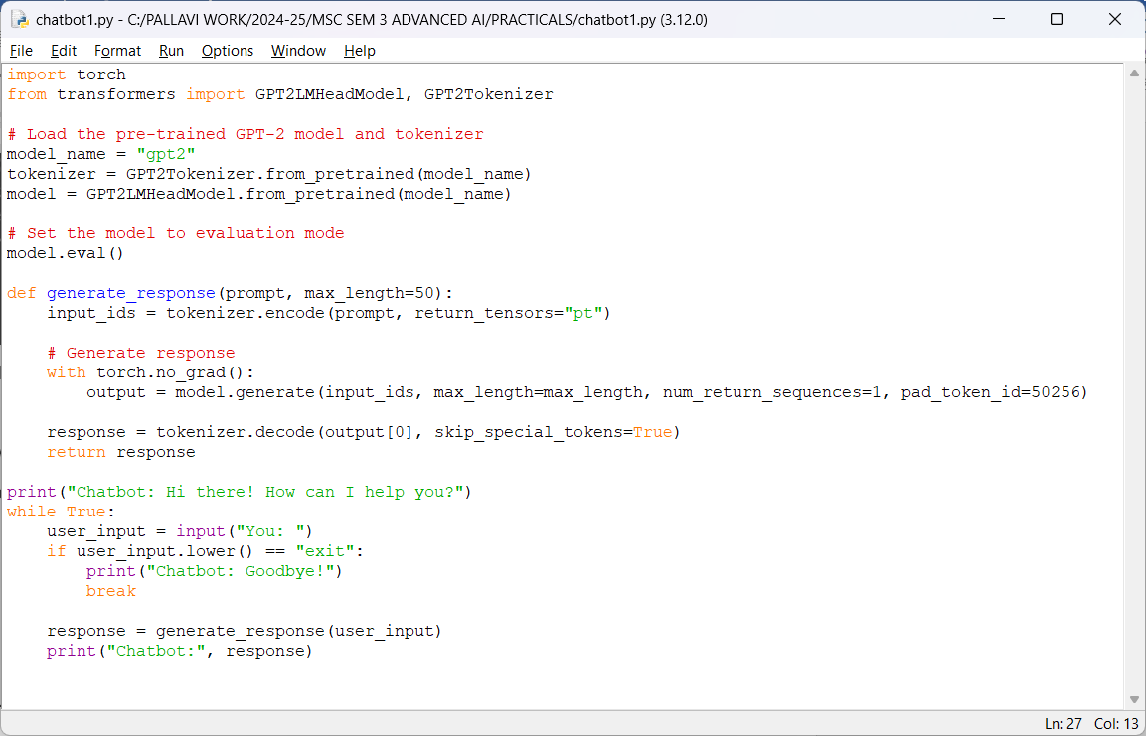

Output:
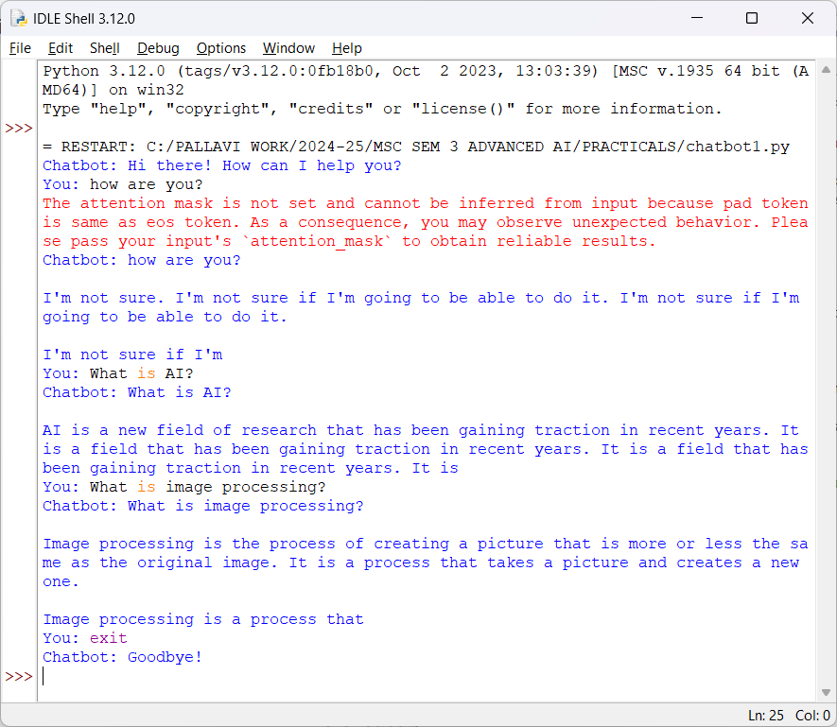

PRACTICAL NO. 04 :
Developing a recommendation system using collaborative filtering or deep learning approaches.

Description :
- Write about recommendation system with its two approaches
- We are performing the above program using deep learning approach, write about this approach.
- Students supposed to write about the library which is installed.

Steps to follow:
You need to install the following library.
pip install numpy pandas tensorflow

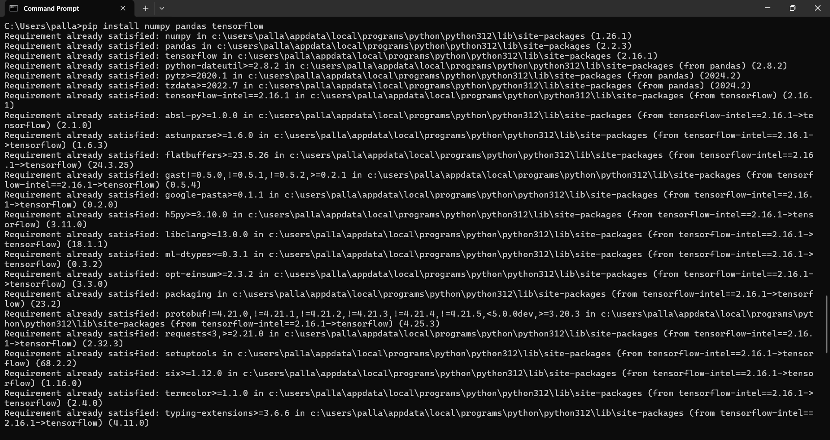

Python code:
import numpy as np
import pandas as pd
import tensorflow as tf
from tensorflow.keras.models import Model
from tensorflow.keras.layers import Embedding, Flatten, Dense, Input, Concatenate
from tensorflow.keras.optimizers import Adam

# Sample dataset
data = {
'user_id': [1, 1, 1, 2, 2, 3, 3, 3, 4, 4],
'item_id': ['A', 'B', 'C', 'A', 'C', 'A', 'B', 'C', 'B', 'C'],
'rating': [5, 4, 3, 4, 5, 3, 2, 5, 5, 3]
}

# Convert the data into a pandas DataFrame
df = pd.DataFrame(data)

# Map item_id and user_id to integers
user_map = {user: idx for idx, user in enumerate(df['user_id'].unique())}
item_map = {item: idx for idx, item in enumerate(df['item_id'].unique())}

df['user_id'] = df['user_id'].map(user_map)
df['item_id'] = df['item_id'].map(item_map)

# Split data into features and labels
X = df[['user_id', 'item_id']].values
y = df['rating'].values

# Define the model architecture for Neural Collaborative Filtering (NCF)
user_input = Input(shape=(1,))
item_input = Input(shape=(1,))

# Embedding layers for users and items
user_embedding = Embedding(input_dim=len(user_map), output_dim=10)(user_input)
item_embedding = Embedding(input_dim=len(item_map), output_dim=10)(item_input)

# Flatten the embeddings
user_embedding = Flatten()(user_embedding)
item_embedding = Flatten()(item_embedding)

# Concatenate the embeddings
merged = Concatenate()([user_embedding, item_embedding])

# Fully connected layers
dense = Dense(128, activation='relu')(merged)
dense = Dense(64, activation='relu')(dense)
output = Dense(1)(dense)

# Compile the model
model = Model(inputs=[user_input, item_input], outputs=output)
model.compile(optimizer=Adam(), loss='mean_squared_error')

# Train the model
model.fit([X[:, 0], X[:, 1]], y, epochs=10, batch_size=2, verbose=1)

# Function to make recommendations for a specific user
def recommend(user_id, top_n=3):
# Get all items
all_items = list(item_map.values())

# Predict ratings for each item for the user
user_input_data = np.array([user_map[user_id]] * len(all_items))
item_input_data = np.array(all_items)

predictions = model.predict([user_input_data, item_input_data])

# Sort the predictions by predicted rating
item_ids_sorted = np.argsort(predictions.flatten())[::-1]

# Get the top_n recommended item IDs
recommended_item_ids = item_ids_sorted[:top_n]

# Convert back to original item IDs
recommended_items = [list(item_map.keys())[list(item_map.values()).index(idx)] for idx in recommended_item_ids]

return recommended_items

# Example: Get top 3 recommendations for user 1
user_id = 1
recommended_items = recommend(user_id)
print(f"Top 3 recommendations for user {user_id}: {recommended_items}")

Output:
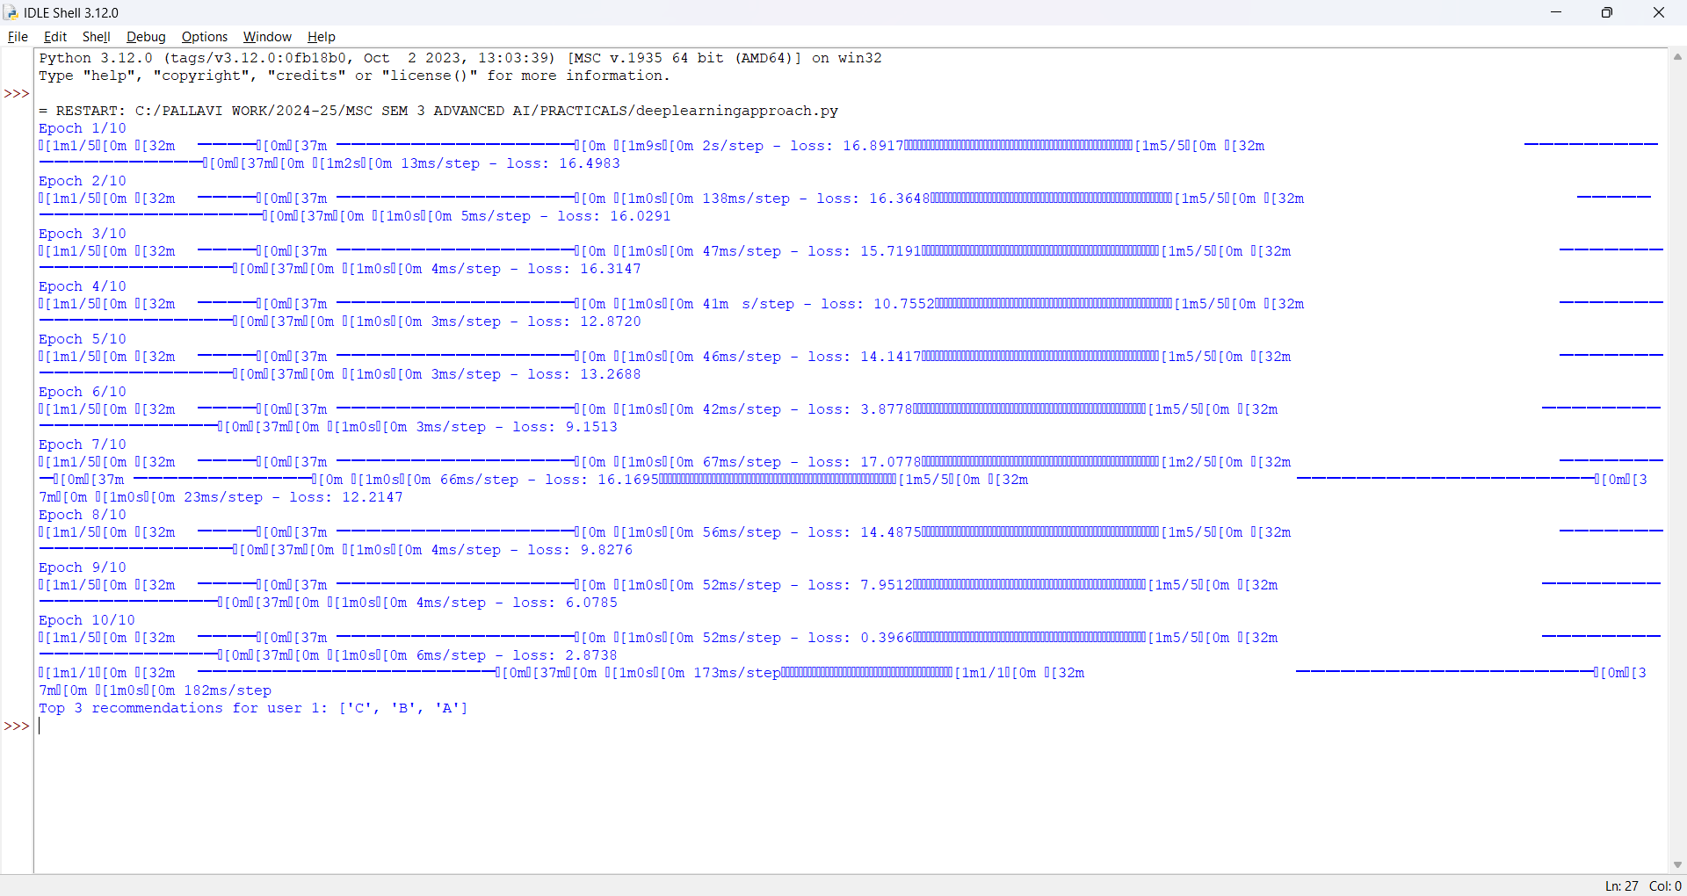

PRACTICAL NO. 5
Implementing a computer vision project, such as object detection or image segmentation.

Object detection

Description :
- Write about object detection
- Students supposed to write about the library which is installed.

Steps to follow:

Step 1 : we need tensorflow module for this program , install it first and then run code.
Create a Virtual Environment (Optional but Recommended): It's a good practice to create a virtual environment for your Python projects to avoid conflicts with other packages. You can create a virtual environment using venv or virtualenv. Here's how to create one using venv:
Steps: open command promt and run the following command:
python -m venv myenv
Replace myenv with the name you want to give to your virtual environment.
Activate the Virtual Environment (Optional): Activate the virtual environment you just created: (on command prompt)
myenv\Scripts\activate
Install TensorFlow: Once your virtual environment is activated, you can install TensorFlow using pip: (on command prompt)
pip install tensorflow
This will install the latest stable version of TensorFlow available on PyPI.
Verify Installation: After installation, you can verify that TensorFlow is installed correctly by opening a Python interpreter and importing TensorFlow , as shown in code.
(note: following is sample window for command prompt)
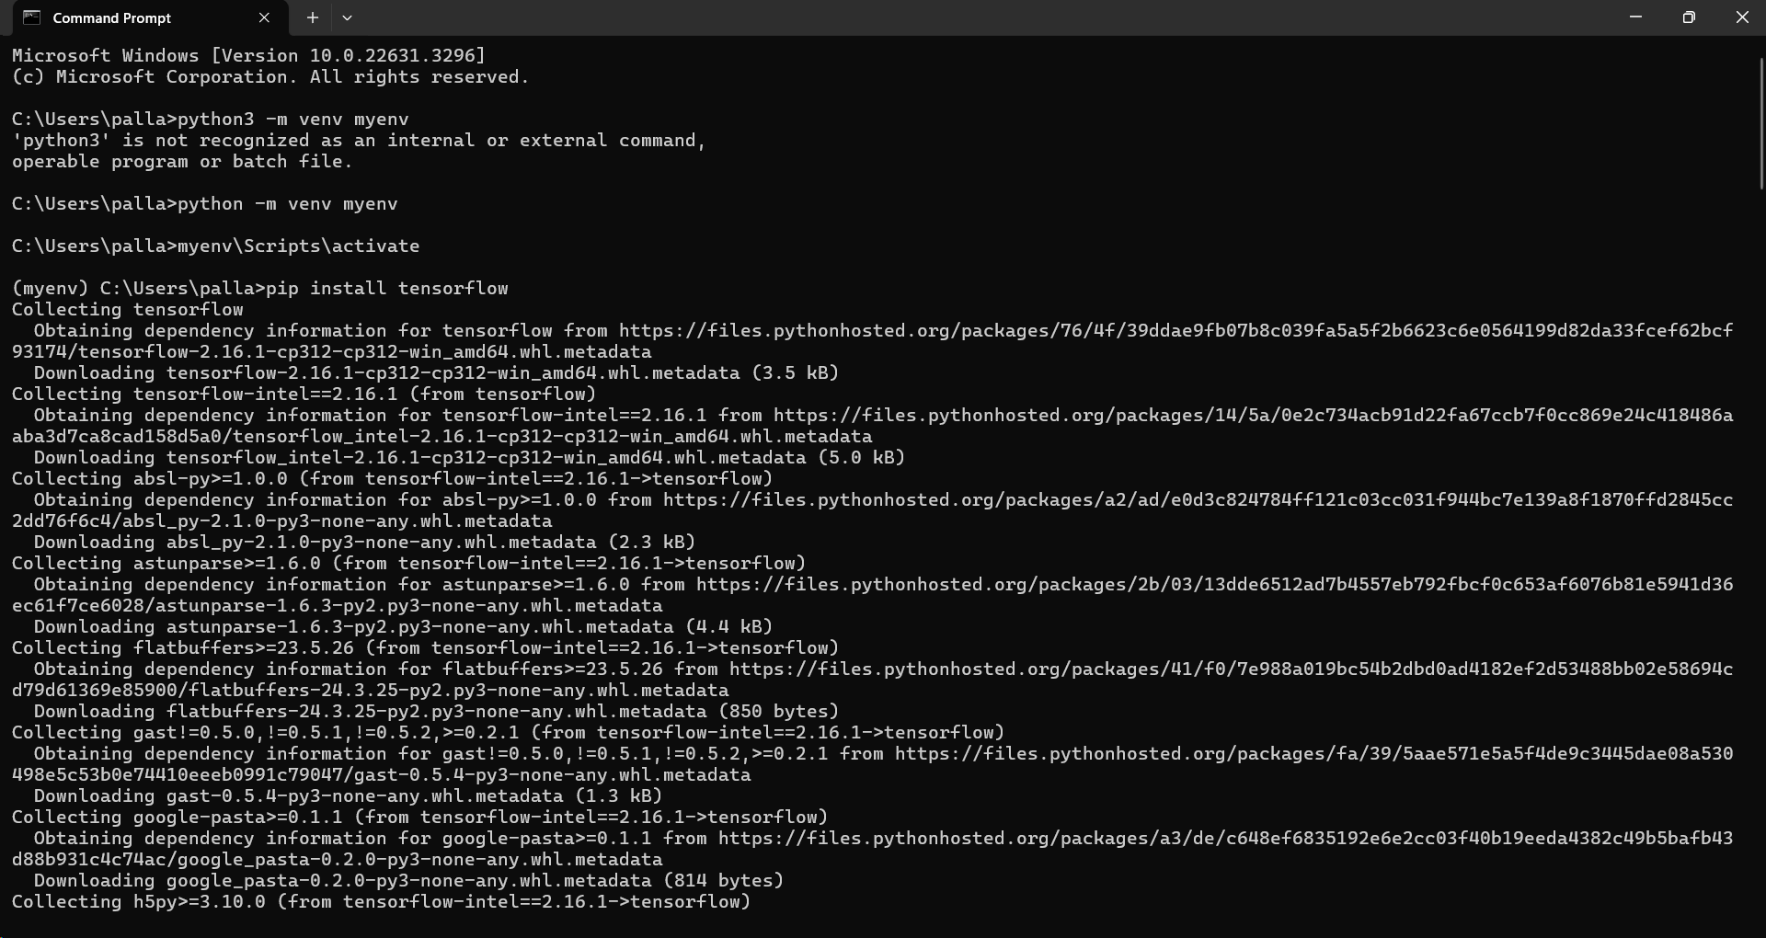
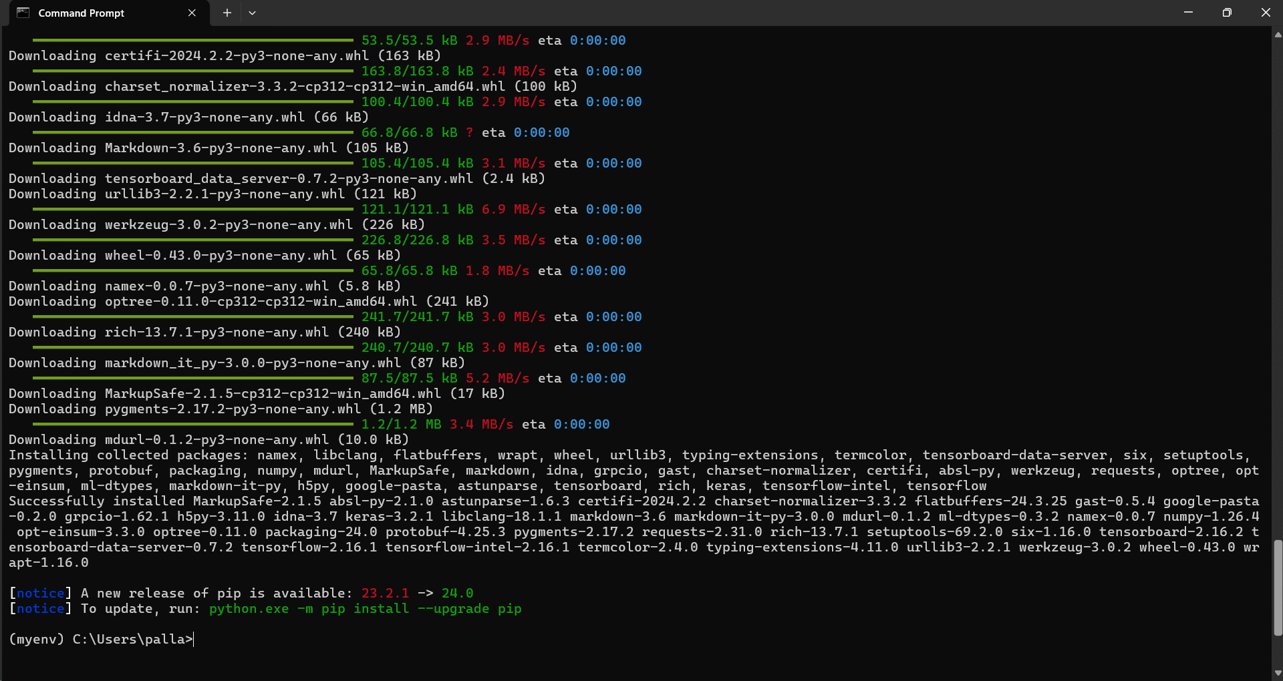
If the above command is not able to install tensorflow then follow the following commands
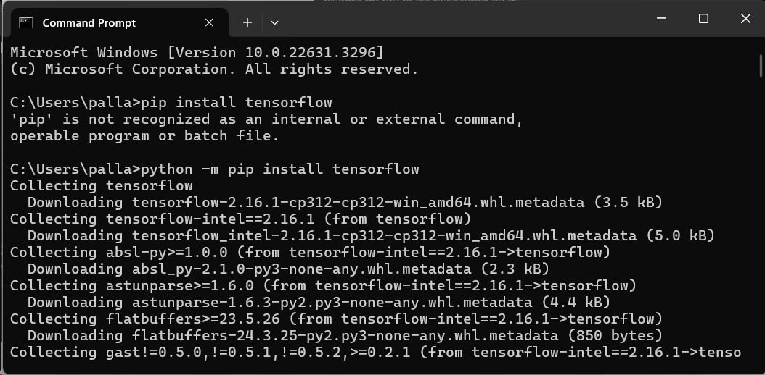

After installing tensorflow you can check it on python : it will show version of tensorflow.
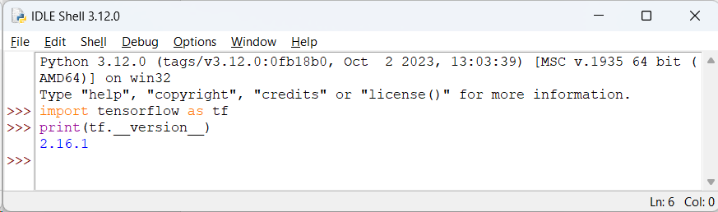

Download the following model from the given link :
http://download.tensorflow.org/models/object_detection/ssd_mobilenet_v2_coco_2018_03_29.tar.gz
- open it in winrar
- extract it at the same path where your python code exists.
- Download the mscoco_label_map.pbtxt from the tensorflow dataset
  - Find the link below to download the file
  - Link: https://github.com/tensorflow/models/blob/master/research/object_detection/data/mscoco_label_map.pbtxt
  - keep the above file in the folder data (you are supposed to create the data folder in the same directory as your python script.)

code:

import numpy as np
import os
import tensorflow as tf
import cv2

# Load the pre-trained model
MODEL_NAME = 'ssd_mobilenet_v2_coco_2018_03_29'
PATH_TO_CKPT = os.path.join(MODEL_NAME, 'frozen_inference_graph.pb')
NUM_CLASSES = 90

detection_graph = tf.Graph()
with detection_graph.as_default():
od_graph_def = tf.compat.v1.GraphDef()
with tf.io.gfile.GFile(PATH_TO_CKPT, 'rb') as fid:
serialized_graph = fid.read()
od_graph_def.ParseFromString(serialized_graph)
tf.import_graph_def(od_graph_def, name='')

# Load label map
#PATH_TO_LABELS = os.path.join('data', 'mscoco_label_map.pbtxt')
PATH_TO_LABELS = "C:\PALLAVI WORK\MSC IT SEM 2 COMPUTER VISION\mscoco_label_map.pbtxt"
category_index = {}
with open(PATH_TO_LABELS, 'r') as f:
lines = f.readlines()
for line in lines:
if 'id:' in line:
id_index = int(line.strip().split(':')[1])
if 'display_name:' in line:
name = line.strip().split(':')[1].strip().strip('"')
category_index[id_index] = {'name': name}

# Function to perform object detection
def detect_objects(image):
with detection_graph.as_default():
with tf.compat.v1.Session(graph=detection_graph) as sess:
# Expand dimensions since the model expects images to have shape: [1, None, None, 3]
image_expanded = np.expand_dims(image, axis=0)
image_tensor = detection_graph.get_tensor_by_name('image_tensor:0')
# Each box represents a part of the image where a particular object was detected.
boxes = detection_graph.get_tensor_by_name('detection_boxes:0')
# Each score represents the level of confidence for each of the objects.
# The score is shown on the result image, together with the class label.
scores = detection_graph.get_tensor_by_name('detection_scores:0')
classes = detection_graph.get_tensor_by_name('detection_classes:0')
num_detections = detection_graph.get_tensor_by_name('num_detections:0')
# Actual detection.
(boxes, scores, classes, num_detections) = sess.run([boxes, scores, classes, num_detections],feed_dict={image_tensor: image_expanded})
# Visualization of the results of a detection.
for i in range(len(scores[0])):
if scores[0][i] > 0.5: # Adjust confidence threshold as needed
class_id = int(classes[0][i])
class_name = category_index[class_id]['name']
score = float(scores[0][i])
ymin, xmin, ymax, xmax = boxes[0][i]
(left, right, top, bottom) = (xmin * image.shape[1], xmax * image.shape[1], ymin * image.shape[0], ymax * image.shape[0])
cv2.rectangle(image, (int(left), int(top)), (int(right), int(bottom)), (0, 255, 0), 2)
cv2.putText(image, '{}: {:.2f}'.format(class_name, score), (int(left), int(top - 5)), cv2.FONT_HERSHEY_SIMPLEX, 0.5, (0, 255, 0), 2)
return image

# Object detection on an image
input_image = cv2.imread("C:\PALLAVI WORK\MSC IT SEM 2 COMPUTER VISION\IMG.jpg")
output_image = detect_objects(input_image)
cv2.imshow('Object Detection', output_image)
cv2.waitKey(0)
cv2.destroyAllWindows()

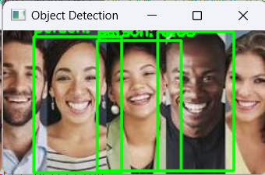

PRACTICAL NO. 6
Training a generative adversarial network (GAN) for generating realistic images

Description :
- Write about GAN
- Students supposed to write about the library which is installed.

Steps to follow:
You need to install the following library.
pip install tensorflow numpy matplotlib
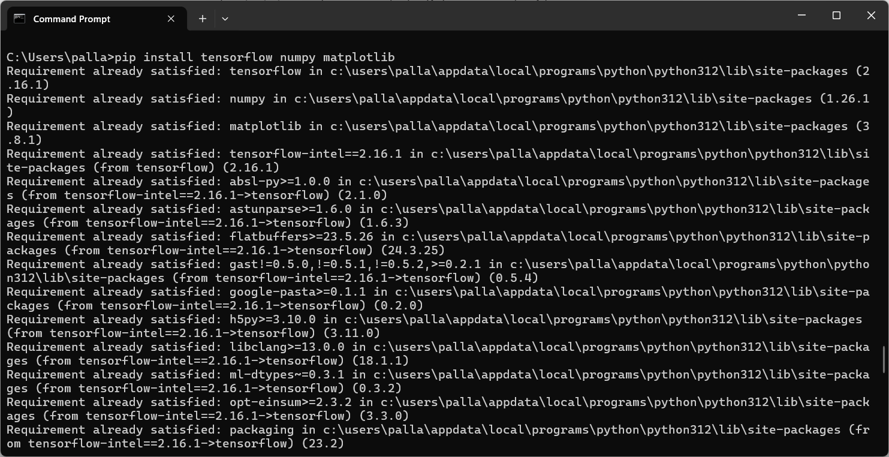
python code:
Note :
for the MNIST dataset (i.e. mnist.npz), download it manually and save it to the following path : "C:\Users\----\.keras\datasets\"
the above mention directory “.keras” is noramally hidden in the system so change the view settings before to copy paste the “mnist.npz”
To download the mnist.npz dataset manually click here:
https://storage.googleapis.com/tensorflow/tf-keras-datasets/mnist.npz
import tensorflow as tf
from tensorflow.keras import layers
import numpy as np
import matplotlib.pyplot as plt
import os

# Set random seed for reproducibility
np.random.seed(42)
tf.random.set_seed(42)

# Load and preprocess MNIST dataset
(x_train, _), (_, _) = tf.keras.datasets.mnist.load_data()

# Normalize the images to the range [-1, 1] for better GAN performance
x_train = x_train.astype('float32')
x_train = (x_train - 127.5) / 127.5 # Normalize to [-1, 1]
x_train = np.expand_dims(x_train, axis=-1) # Add channel dimension (1, height, width, 1)

# Set parameters
latent_dim = 100 # Dimension of the latent space (noise)
batch_size = 64
epochs = 10000
save_interval = 1000

# Create the Generator model
def build_generator():
model = tf.keras.Sequential()

# Fully connected layer with ReLU activation
model.add(layers.Dense(128 * 7 * 7, input_dim=latent_dim)) # Output enough features for reshape
model.add(layers.LeakyReLU(0.2))
model.add(layers.BatchNormalization(momentum=0.8))

# Reshape the output of the Dense layer into a 3D tensor (7x7x128)
model.add(layers.Reshape((7, 7, 128))) # 7x7 image with 128 filters

# Upsample to 14x14
model.add(layers.Conv2DTranspose(128, kernel_size=3, strides=2, padding='same'))
model.add(layers.LeakyReLU(0.2))
model.add(layers.BatchNormalization(momentum=0.8))

# Upsample to 28x28
model.add(layers.Conv2DTranspose(64, kernel_size=3, strides=2, padding='same'))
model.add(layers.LeakyReLU(0.2))
model.add(layers.BatchNormalization(momentum=0.8))

# Final layer: 28x28 image with tanh activation
model.add(layers.Conv2DTranspose(1, kernel_size=3, strides=1, padding='same', activation='tanh'))

return model

# Create the Discriminator model
def build_discriminator():
model = tf.keras.Sequential()

# Convolutional layers with LeakyReLU activations
model.add(layers.Conv2D(64, kernel_size=3, strides=2, padding='same', input_shape=(28, 28, 1)))
model.add(layers.LeakyReLU(0.2))
model.add(layers.Dropout(0.25))

model.add(layers.Conv2D(128, kernel_size=3, strides=2, padding='same'))
model.add(layers.LeakyReLU(0.2))
model.add(layers.Dropout(0.25))

model.add(layers.Flatten())
model.add(layers.Dense(1, activation='sigmoid')) # Output a single value (real/fake)

return model

# Build the GAN model by combining the Generator and the Discriminator
def build_gan(generator, discriminator):
# Freeze the discriminator during GAN training (we only train the generator)
discriminator.trainable = False

gan_input = layers.Input(shape=(latent_dim,))
x = generator(gan_input)
gan_output = discriminator(x)

gan = tf.keras.Model(gan_input, gan_output)
return gan

# Compile the Discriminator and GAN
discriminator = build_discriminator()
discriminator.compile(optimizer=tf.keras.optimizers.Adam(learning_rate=0.0002, beta_1=0.5), loss='binary_crossentropy', metrics=['accuracy'])

generator = build_generator()
gan = build_gan(generator, discriminator)
gan.compile(optimizer=tf.keras.optimizers.Adam(learning_rate=0.0002, beta_1=0.5), loss='binary_crossentropy')

# Function to train the GAN
def train_gan(epochs, batch_size, save_interval):
half_batch = batch_size // 2 # Half the batch size for real and fake

# Adversarial ground truths
valid = np.ones((batch_size, 1)) # Change to match full batch size
fake = np.zeros((batch_size, 1)) # Change to match full batch size

for epoch in range(epochs):

# Train Discriminator
idx = np.random.randint(0, x_train.shape[0], half_batch)
real_images = x_train[idx]

# Generate fake images
noise = np.random.normal(0, 1, (half_batch, latent_dim))
generated_images = generator.predict(noise)

# Train on real images
d_loss_real = discriminator.train_on_batch(real_images, valid[:half_batch]) # Use only half batch for real
# Train on fake images
d_loss_fake = discriminator.train_on_batch(generated_images, fake[:half_batch]) # Use only half batch for fake
d_loss = 0.5 * np.add(d_loss_real, d_loss_fake)

# Train Generator via GAN
noise = np.random.normal(0, 1, (batch_size, latent_dim))
g_loss = gan.train_on_batch(noise, valid) # Use full batch for generator

# Print the progress
if epoch % save_interval == 0:
print(f"{epoch}/{epochs} [D loss: {d_loss[0]} | D accuracy: {100 * d_loss[1]}] [G loss: {g_loss}]")
save_generated_images(epoch)

# Function to save generated images
def save_generated_images(epoch, examples=10, dim=(1, 10), figsize=(10, 1)):
noise = np.random.normal(0, 1, (examples, latent_dim))
generated_images = generator.predict(noise)
generated_images = (generated_images + 1) / 2.0 # Rescale images to [0, 1]

# Plot and save images
plt.figure(figsize=figsize)
for i in range(examples):
plt.subplot(dim[0], dim[1], i + 1)
plt.imshow(generated_images[i, :, :, 0], cmap='gray')
plt.axis('off')

plt.tight_layout()
plt.savefig(f"gan_generated_image_{epoch}.png")
plt.close()

# Train the GAN
train_gan(epochs, batch_size, save_interval)

output:
The following process will get over after 10,000 epoch and it will generate the gan_generated_image_0.png type of images at your working directory.
Eg. 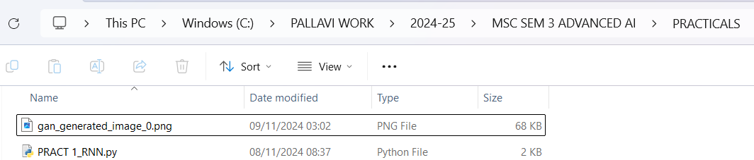

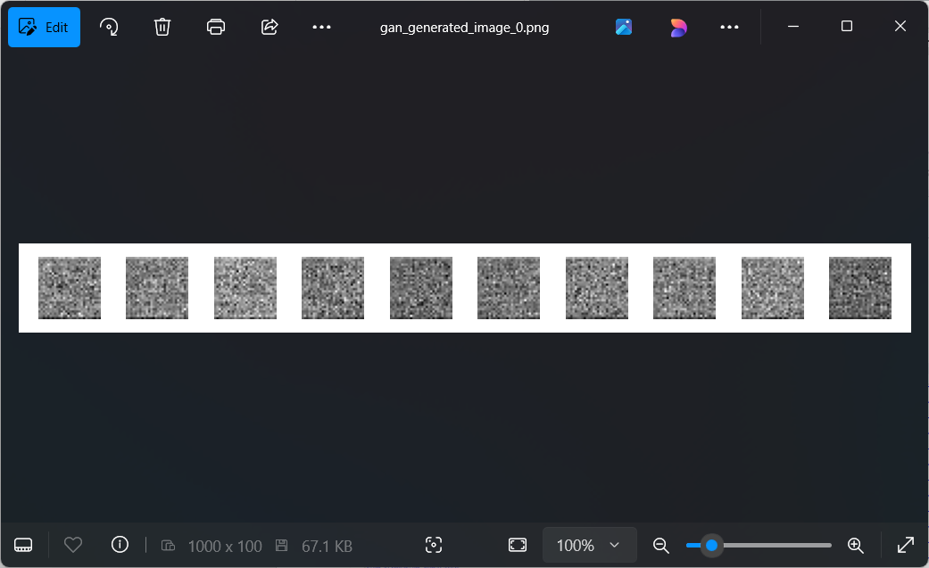
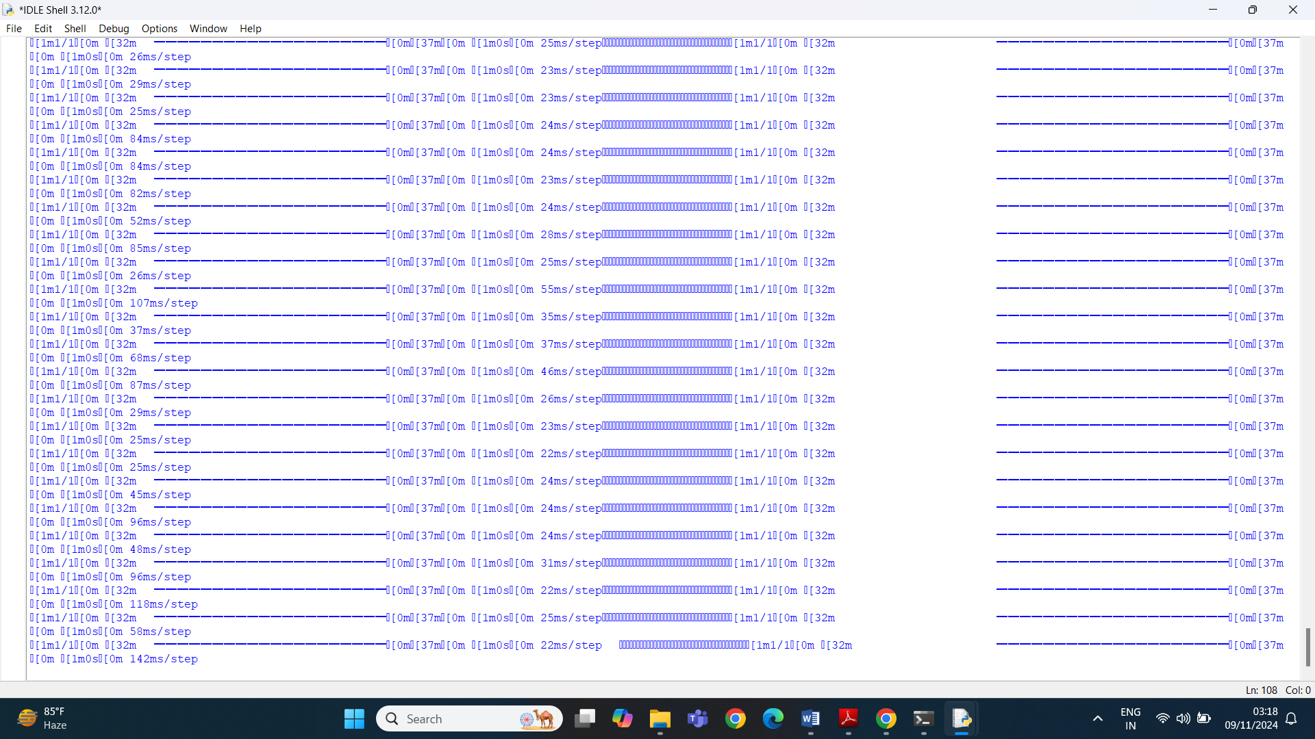

PRACTICAL NO. 7
Applying reinforcement learning algorithms to solve complex decision-making problems.

Description :
- Write about reinforcement learning and Q learning technique.

Python code:
import numpy as np
import random
import matplotlib.pyplot as plt

# Define the environment size (grid dimensions)
grid_size = (5, 5) # 5x5 grid
goal_state = (4, 4) # goal is at the bottom-right corner
start_state = (0, 0) # start at the top-left corner

# Define the actions
actions = ['up', 'down', 'left', 'right']
action_map = {'up': (-1, 0), 'down': (1, 0), 'left': (0, -1), 'right': (0, 1)}

# Q-learning parameters
learning_rate = 0.1 # Alpha
discount_factor = 0.9 # Gamma
epsilon = 0.1 # Epsilon for epsilon-greedy policy
num_episodes = 1000 # Number of episodes for training
max_steps_per_episode = 100 # Maximum steps per episode

# Initialize Q-table (state-action value table)
q_table = np.zeros((grid_size[0], grid_size[1], len(actions)))

# Reward function: -1 for each step, +100 for reaching the goal
def reward_function(state):
if state == goal_state:
return 100 # reward for reaching the goal
return -1 # penalty for each step

# Choose action based on epsilon-greedy policy
def choose_action(state):
if random.uniform(0, 1) < epsilon:
# Exploration: random action
return random.choice(actions)
else:
# Exploitation: choose the best action based on Q-table
state_x, state_y = state
q_values = q_table[state_x, state_y, :]
max_q_value = np.max(q_values)
max_actions = [actions[i] for i in range(len(actions)) if q_values[i] == max_q_value]
return random.choice(max_actions)

# Take action and get the next state
def take_action(state, action):
state_x, state_y = state
move = action_map[action]
new_x = max(0, min(grid_size[0] - 1, state_x + move[0])) # Ensure we don't go out of bounds
new_y = max(0, min(grid_size[1] - 1, state_y + move[1])) # Ensure we don't go out of bounds
return (new_x, new_y)

# Q-learning algorithm
def train_q_learning():
for episode in range(num_episodes):
state = start_state
total_reward = 0

for step in range(max_steps_per_episode):
action = choose_action(state)
next_state = take_action(state, action)
reward = reward_function(next_state)

# Update Q-value using the Q-learning formula
state_x, state_y = state
next_state_x, next_state_y = next_state
action_index = actions.index(action)

# Bellman equation: Q(s, a) = Q(s, a) + alpha * [reward + gamma * max(Q(s', a')) - Q(s, a)]
max_future_q = np.max(q_table[next_state_x, next_state_y, :])
q_table[state_x, state_y, action_index] += learning_rate * (reward + discount_factor * max_future_q - q_table[state_x, state_y, action_index])

state = next_state
total_reward += reward

# If the agent reaches the goal, break the episode
if state == goal_state:
break

if (episode + 1) % 100 == 0:
print(f"Episode {episode + 1} completed")

# Visualization of learned policy (after training)
def visualize_policy():
policy_grid = np.full(grid_size, '', dtype=object)
for x in range(grid_size[0]):
for y in range(grid_size[1]):
best_action_index = np.argmax(q_table[x, y, :])
best_action = actions[best_action_index]
policy_grid[x, y] = best_action[0].upper() # Show the first letter of the best action

# Plotting the policy grid
plt.figure(figsize=(6, 6))
plt.imshow(np.zeros(grid_size), cmap="Blues", interpolation='none')
for x in range(grid_size[0]):
for y in range(grid_size[1]):
plt.text(y, x, policy_grid[x, y], ha='center', va='center', color='black', fontsize=12)

plt.title("Learned Policy (Q-learning)")
plt.xticks(range(grid_size[1]))
plt.yticks(range(grid_size[0]))
plt.gca().invert_yaxis()
plt.show()

# Train the agent using Q-learning
train_q_learning()

# Visualize the learned policy
visualize_policy()

Output:
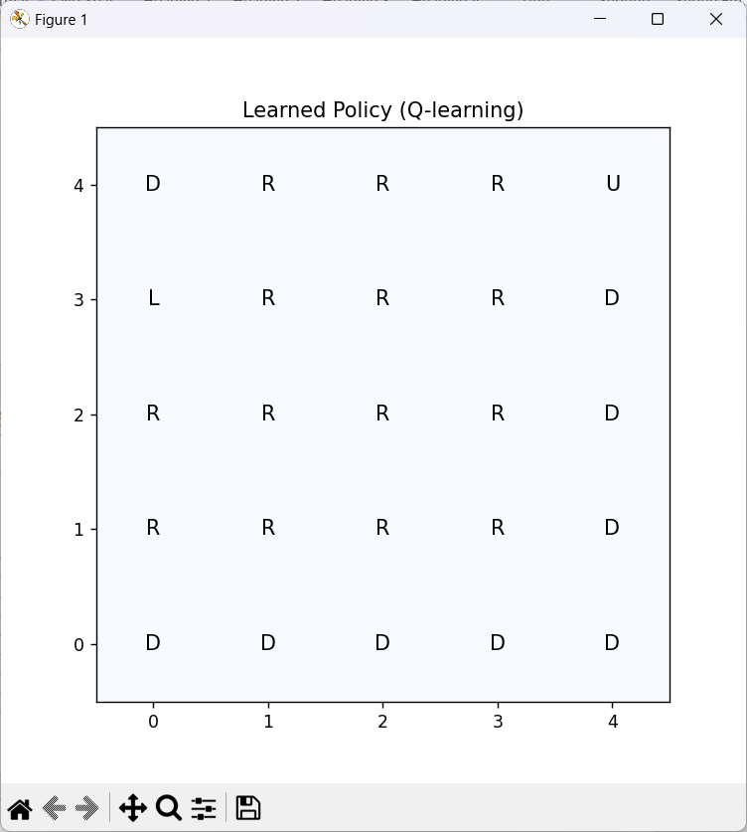
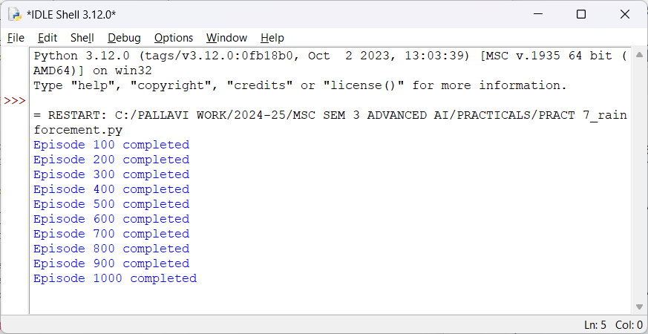

PRACTICAL NO 8 (practical no 13 in the syllabus)
Use Python libraries such as GPT-2 or textgenrnn to train generative models on a corpus of text data and generate new text based on the patterns it has learned.

Description :
- Write about GPT-2 and textgenrnn and text patterns
- Students supposed to write about the library which is installed.
Steps to follow:
You need to install the following library.
pip install transformers datasets torch
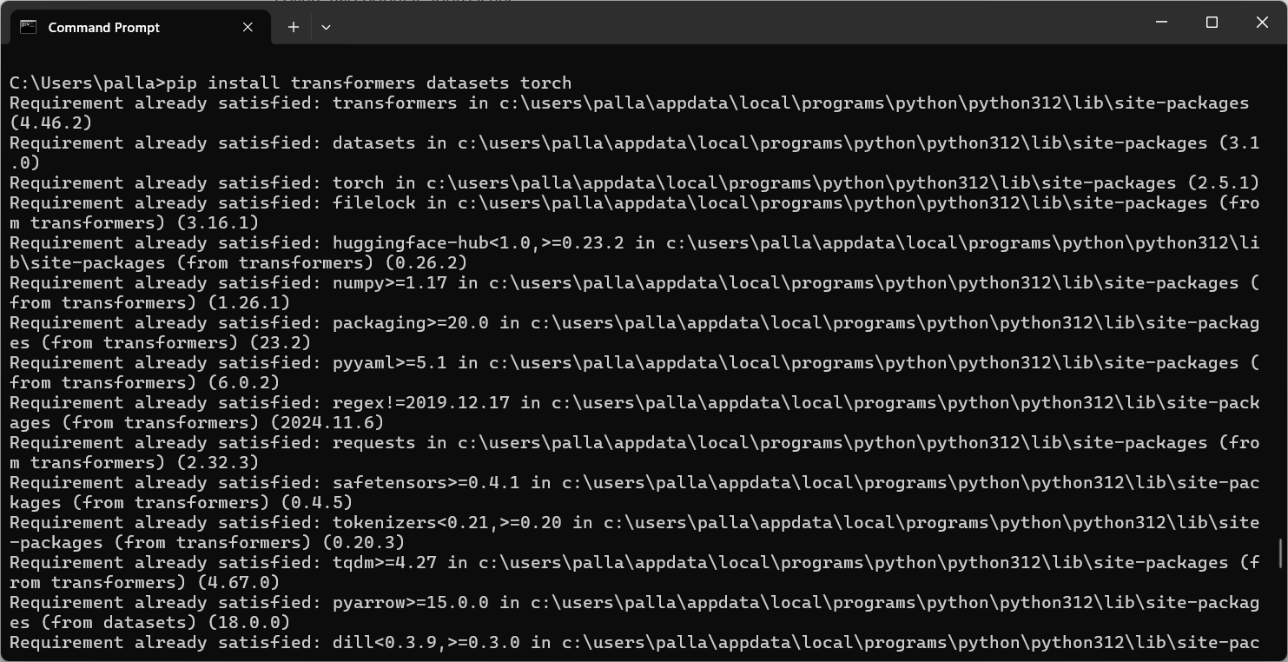
Note: if the above installed library is not working then try the one given below:
install following library:
pip install transformers torch
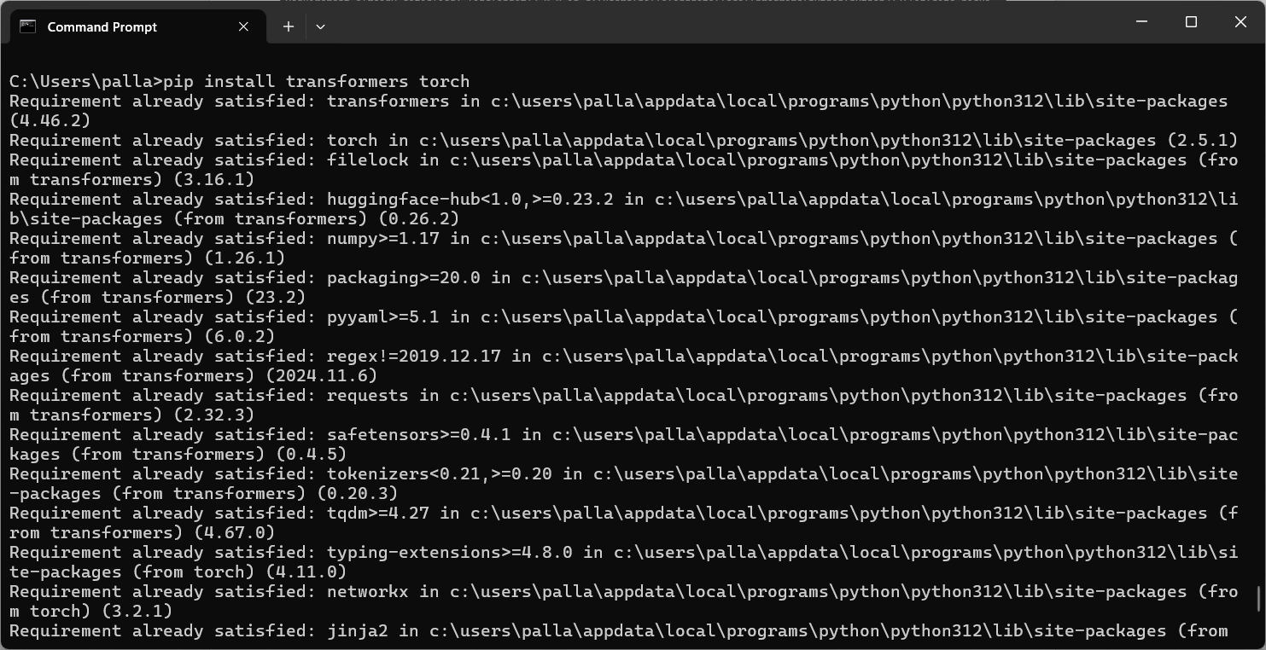

PYTHON CODE: Code to Generate Text with GPT-2
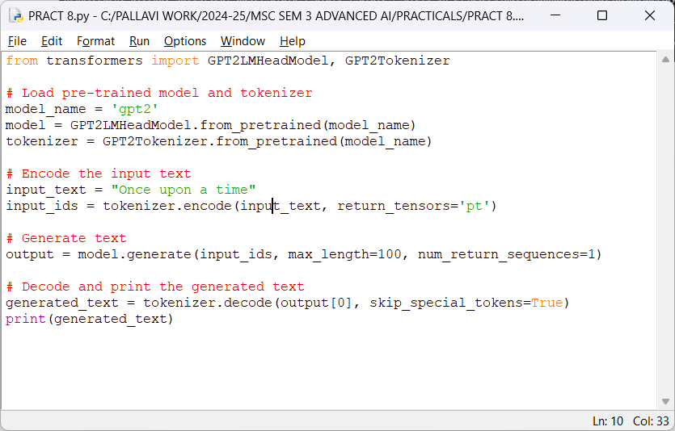

from transformers import GPT2LMHeadModel, GPT2Tokenizer

# Load pre-trained model and tokenizer
model_name = 'gpt2'
model = GPT2LMHeadModel.from_pretrained(model_name)
tokenizer = GPT2Tokenizer.from_pretrained(model_name)

# Encode the input text
input_text = "Once upon a time"
input_ids = tokenizer.encode(input_text, return_tensors='pt')

# Generate text
output = model.generate(input_ids, max_length=100, num_return_sequences=1)

# Decode and print the generated text
generated_text = tokenizer.decode(output[0], skip_special_tokens=True)
print(generated_text)

OUTPUT:
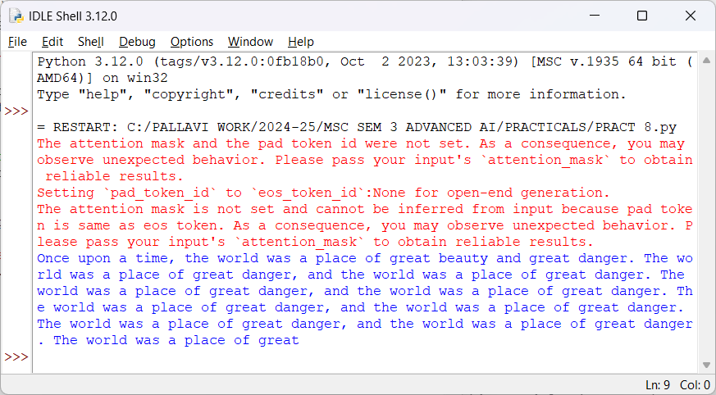
Every time you run the above code it will generate the different story starts with “once one a time”
PRACTICAL NO. 09 (practical no. 14 from syllabus)
Experiment with neural networks like GANs (Generative Adversarial Networks) using Python libraries like TensorFlow or PyTorch to generate new images based on a dataset of images.

Description :
- Write about GAN
- Students supposed to write about the library which is installed.
Steps to follow:
You need to install the following library.
pip install torch torchvision matplotlib
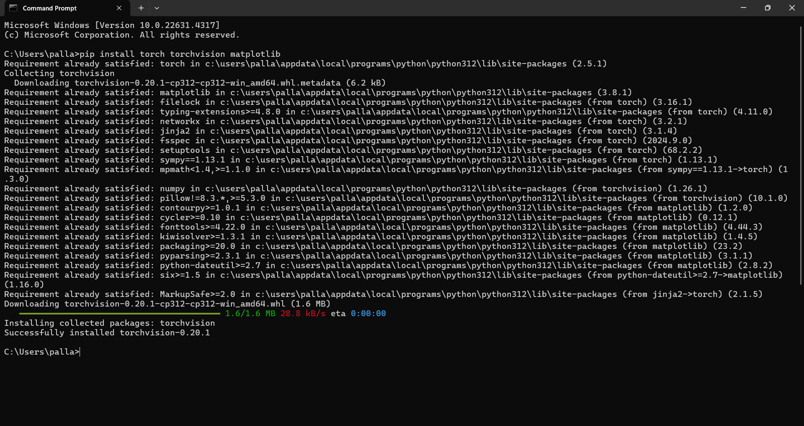
Python code:
we will use PyTorch for creating the GAN to generate images based on the MNIST dataset which is common dataset.
Total 50 epoch mentioned in the code, you can minimize it. And after every 10 epochs, the generated images will be saved as .png files in the generated_images/ at working directory.
Each image is saved as epoch_{epoch_number}.png (e.g., epoch_10.png, epoch_20.png).

import torch
import torch.nn as nn
import torch.optim as optim
import torchvision
import torchvision.transforms as transforms
import matplotlib.pyplot as plt
import os
import torchvision.utils as vutils
from torch.utils.data import DataLoader

# Generator Model
class Generator(nn.Module):
def __init__(self):
super(Generator, self).__init__()
self.fc1 = nn.Linear(100, 256)
self.fc2 = nn.Linear(256, 512)
self.fc3 = nn.Linear(512, 1024)
self.fc4 = nn.Linear(1024, 784)
self.relu = nn.ReLU()
self.tanh = nn.Tanh()

def forward(self, z):
x = self.relu(self.fc1(z))
x = self.relu(self.fc2(x))
x = self.relu(self.fc3(x))
x = self.tanh(self.fc4(x)) # Output is in the range [-1, 1]
return x.view(-1, 1, 28, 28) # Reshape to 28x28 image

# Discriminator Model
class Discriminator(nn.Module):
def __init__(self):
super(Discriminator, self).__init__()
self.fc1 = nn.Linear(784, 1024)
self.fc2 = nn.Linear(1024, 512)
self.fc3 = nn.Linear(512, 256)
self.fc4 = nn.Linear(256, 1)
self.leaky_relu = nn.LeakyReLU(0.2)
self.sigmoid = nn.Sigmoid()

def forward(self, x):
x = x.view(-1, 784) # Flatten the image to a vector
x = self.leaky_relu(self.fc1(x))
x = self.leaky_relu(self.fc2(x))
x = self.leaky_relu(self.fc3(x))
x = self.sigmoid(self.fc4(x)) # Output is between 0 and 1
return x

# Load MNIST dataset
def load_data():
transform = transforms.Compose([
transforms.ToTensor(),
transforms.Normalize((0.5,), (0.5,))
])
train_dataset = torchvision.datasets.MNIST(root='./data', train=True, download=True, transform=transform)
train_loader = DataLoader(train_dataset, batch_size=64, shuffle=True)
return train_loader

# Train the GAN
def train_gan(generator, discriminator, train_loader, num_epochs=50, lr=0.0002, beta1=0.5, output_dir="generated_images"):
# Create output directory if it doesn't exist
if not os.path.exists(output_dir):
os.makedirs(output_dir)

# Define loss and optimizers
criterion = nn.BCELoss()
optimizer_g = optim.Adam(generator.parameters(), lr=lr, betas=(beta1, 0.999))
optimizer_d = optim.Adam(discriminator.parameters(), lr=lr, betas=(beta1, 0.999))

# Labels
real_label = 1
fake_label = 0

for epoch in range(num_epochs):
for i, (real_images, _) in enumerate(train_loader):
# Generate random noise
z = torch.randn(real_images.size(0), 100) # Latent vector size = 100
real_labels = torch.ones(real_images.size(0), 1)
fake_labels = torch.zeros(real_images.size(0), 1)

# Train Discriminator with real images
optimizer_d.zero_grad()
output_real = discriminator(real_images)
loss_real = criterion(output_real, real_labels)
loss_real.backward()

# Train Discriminator with fake images generated by the Generator
fake_images = generator(z)
output_fake = discriminator(fake_images.detach()) # Detach to avoid backprop through the generator
loss_fake = criterion(output_fake, fake_labels)
loss_fake.backward()
optimizer_d.step()

# Train Generator to fool the Discriminator
optimizer_g.zero_grad()
output_fake_g = discriminator(fake_images)
loss_g = criterion(output_fake_g, real_labels) # Want the discriminator to classify fake as real
loss_g.backward()
optimizer_g.step()

# Print the losses
if (i + 1) % 100 == 0:
print(f"Epoch [{epoch+1}/{num_epochs}], Step [{i+1}/{len(train_loader)}], "
f"D Loss: {loss_real.item() + loss_fake.item():.4f}, G Loss: {loss_g.item():.4f}")

# Save generated images at the end of each epoch
if (epoch + 1) % 10 == 0:
with torch.no_grad():
fake_images = generator(torch.randn(64, 100)) # Generate 64 fake images
fake_images = fake_images.cpu().detach()
# Save the generated images as a grid
vutils.save_image(fake_images, os.path.join(output_dir, f'epoch_{epoch+1}.png'), nrow=8, normalize=True)
print(f"Generated images saved to {output_dir}/epoch_{epoch+1}.png")

# Main function to run everything
if __name__ == "__main__":
# Load dataset
train_loader = load_data()

# Create models
generator = Generator()
discriminator = Discriminator()

# Start training the GAN
train_gan(generator, discriminator, train_loader)

# Save models
torch.save(generator.state_dict(), 'generator.pth')
torch.save(discriminator.state_dict(), 'discriminator.pth')
print("Models saved as 'generator.pth' and 'discriminator.pth'")

output:

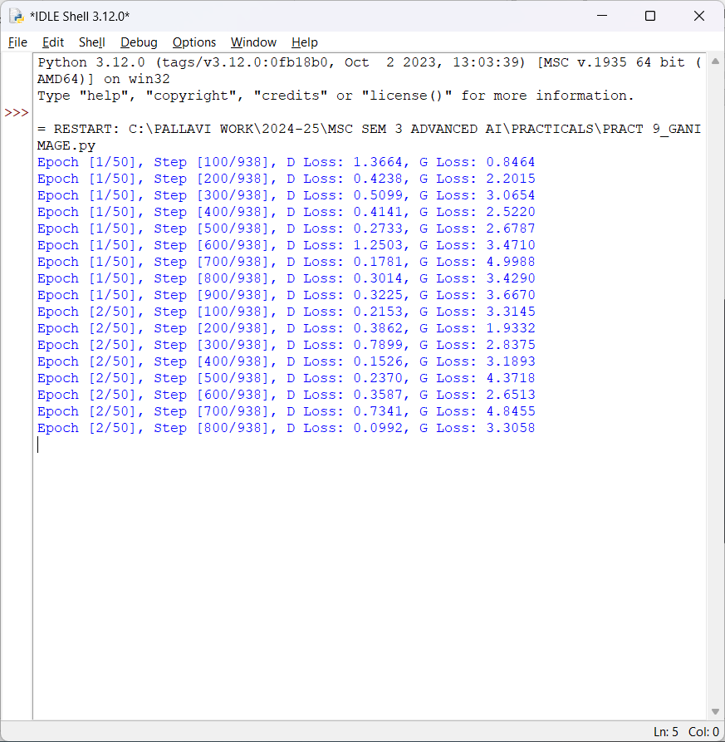

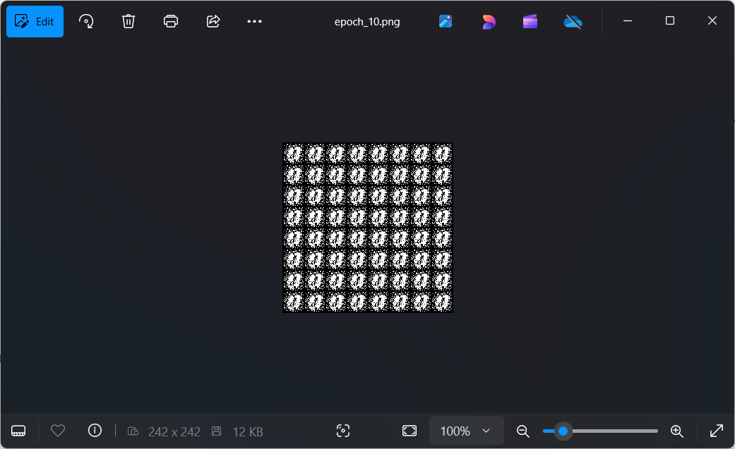

PRACTICAL NO. 10 (practical no. 11 from syllabus)
Using advanced optimization techniques like evolutionary algorithms or Bayesian optimization for hyperparameter tuning.

Description :
- Write about
- Students supposed to write about the library which is installed.
Steps to follow:
You need to install the following library.

